**Contents:**

* 79 cards
  + 12 Queens
    - 8 Kings
    - 5 Jesters
    - 4 Knights
    - 4 Sleeping Potions
    - 3 Wands
    - 3 Dragons
    - 4 of each number 1 through 10

**Object:**

* The object of the game is to be the first player to:
  + Collect 5 queens or >= 50 points in a 2-3 player game
  + Collect 4 queens or >= 40 points in a 4-5 player game
  + Have the most points when all the queens have been awakened

**Setup:**

* Shuffle 12 queen cards and place them face down (asleep) in the center of the playing area in four rows of three. Then shuffle the red backed deck, deal five cards to each player, and place the remaining cards face down in a draw pile in the center of the queens. Player will discard cards onto a face up pile next to the draw pile.

**How to play:**

* 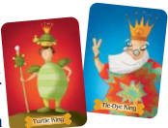On your turn, take **ONE** of the following actions, then draw cards:
  + **King:** *Play a King to* ***awaken*** *a Sleeping Queen from the playing area*. Place your king face up on the discard pile, then pick any queen from the center area and place it face up in front you so that all players can see. The queen is now “awake”.
  + ****Knight:** *Play a Knight to* ***steal*** *any one of your opponents’* ***awakened******queens****.* Place the knight onto the discard pile, then select any one of your opponents’ queens and place it face up in front of you.
  + **Dragons:** *Your opponent can stop your knight by playing a Dragon card from their hand*. **Discard** both **Dragon** and **Knight** cards and **each player** **picks a card** from the draw pile. This does not count as a turn for the Dragon card player. Play **continues** to the **left** of the **Knight** card **player**.
  + 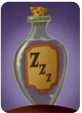**Sleeping potions:** *Play a Sleeping Potion card to* ***put*** *any one of your* ***opponents’ awakened queens*** *back to* ***sleep****.* Place the Sleeping Potion card on the discard pile, then select one of your opponents’ queens and put it face down in any empty space among the other Sleeping Queens.
  + **Wands:** *Your opponent can stop your Sleeping Potion by playing a Wand card from their hand.* **Discard** both **Wand** and **Sleeping Potion** cards and **each player picks a card** from the draw pile. This does not count as a turn for the Wand card player. Play **continues** to the **left** of the Sleeping Potion card **player**.
  + **Jester:** *Play a Jester card and take a chance! Place the Jester card face up on the discard pile, then turn the top draw pile card face up*. If it is a **powerful card (King, Knight, Dragon, Potion, Wand, Jester)**, ***add it*** to ***your hand*** and **take another turn**. If it is a **number card**, starting with you and continuing to the left, count off the number of players equal to the number on the card. The **last player counted gets to awaken and keep a queen from the center!**

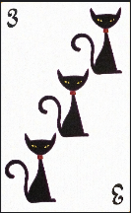

* **For number card:**
  + 1. **Discard** a *single card* of any kind and *draw one card*
  + 2. **Discard** *pair* of *identical number cards* and *draw two cards*

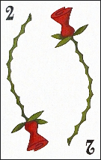

* + 3. **Discard** *three* or *more number cards* that **make a sum equation** and *draw three* or *more cards*. For example: If you have numbers 2, 3 and 5, you can discard all three cards since 2 + 3 = 5. Or if you have a 2, 3, 4 and 9, you can discard them all since 2 + 3 + 4 = 9.

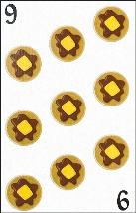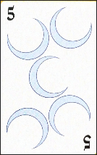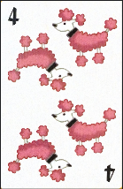

* **Don’t forget**: *At the end of each turn*, player hands will ***fill back to five cards***.

**Special Queen Powers**

* 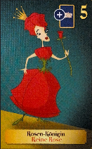**The Rose Queen**, while only worth 5 points, ***has the special ability to take another queen*** with her ***if awakened from the center***. If you *find* the *Rose Queen*, you can *select* another *Sleeping Queen*. If the Rose Queen **taken** by **Knight** card. It ***could not use the ability***.
* You **can not simultaneously** hold **both** the **Cat Queen** and the **Dog Queen** because they fight like cats and dogs! For example: If you have the Cat Queen and then wake up Dog Queen, you must put it back face down and end your turn.

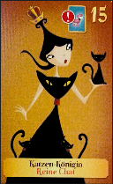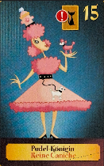

**Ending the game:**

* The **first player** to collect **5 queens** or **50 points** worth of queens in a **2—3 player game**, or ***4 queens*** or ***40 points*** worth of queens in ***a 4—5 player*** game wins. *Points* are *counted* by *adding* up the *numbers* on each *awakened queen*. Alternately, **play ends** when there are **no** more **Sleeping Queens left** in the center and whoever **has** the **most points wins.**

More rules:

* If the draw pile *runs out*, it will ***automatically reshuffle*** the discard pile to start a new draw pile.